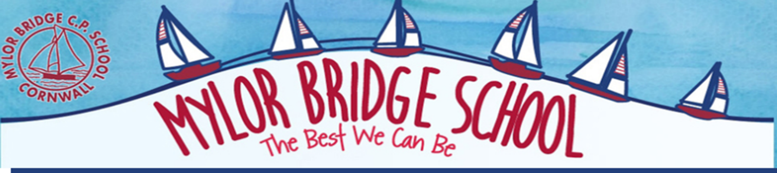
Phonics Intent Statement

Intent
At Mylor Bridge, we are passionate about ensuring all children become confident and enthusiastic readers and writers. We believe that phonics provides the foundations of learning to make the development into fluent reading and writing easier. Through daily, systematic and consistent high quality phonics teaching, children learn to segment words to support their spelling ability and blend sounds to read words. To allow our children to develop a strong phonic awareness and effective blending and decoding skills, we have chosen to use a synthetic phonics programme called ‘Twinkl phonics’, which has been developed using the ‘Letters and Sounds’ model. This is a method of learning centred around letter sounds and phonics, blending sounds together to read and spell words and applying these skills across the curriculum. Using Twinkl Phonics, the children learn to read fluently so that they can put all their energy into comprehending what they read. We believe that teaching children to read and write independently is one of the core purposes of a primary school enabling them to access a broad and exciting curriculum and ensuring they flourish as learners throughout their time at our school. These fundamental skills not only hold the keys to the rest of the curriculum but also have a huge impact on children’s self-esteem and future life chances.

Implementation
The use of the Twinkl phonics scheme allows our teaching and learning of phonics to be progressive from our reception children all the way through to Year 2 and into lower KS2 for those children who need this. All children in EYFS and KS1 have discrete, daily phonics sessions, lasting 30 minutes where they follow the lesson structure as set out in letters and sounds:
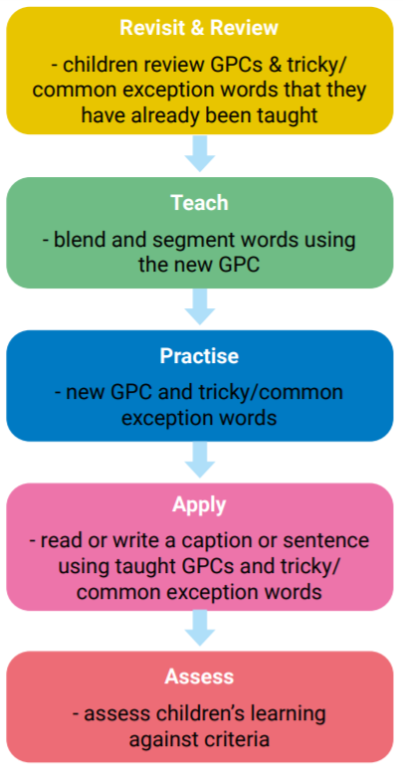
Through Twinkl Phonics, the children are taught the 44 phonemes that make up all the sounds required for reading and spelling. These phonemes include those made by just one letter and those that are made by two or more. Children work through the different phases and as they grow in confidence and experience, they are introduced to alternative ways of representing the same sound.

We begin in reception, by teaching level (or phase) 2, which is the beginning of the systematic phonics programme. The children are then able to work through the scheme systematically, taking small steps to ensure they are able to embed and apply what they have learnt.
The order in which children learn the 44 sounds and their related graphemes is outlined below.
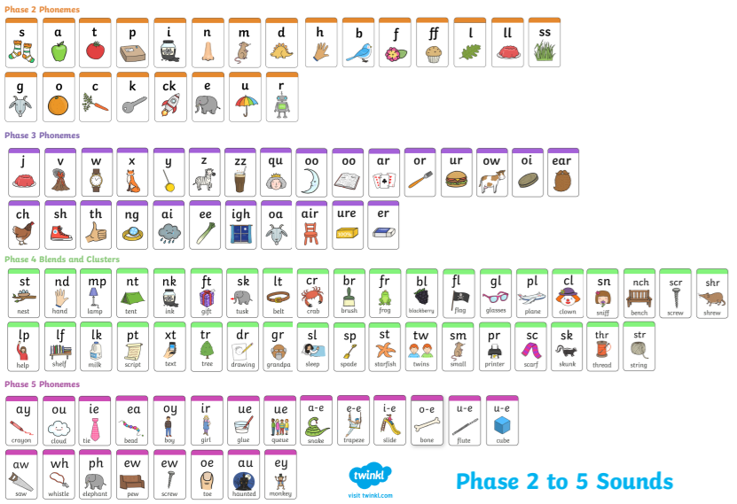
Throughout EYFS and KS1, children are taught in small and focussed groups to target their specific needs for phonics, alongside children of the same ability. These groupings are based on half-termly assessments that are carried out at the start of each school year and then continue half termly. The phonics lead then collates this information and regroups children based on their current skill level, allowing progression for most children but repetition and support for those that need more time on a specific set of sounds. This approach allows lessons to be focused and specific to the needs of the children. These assessments are also used to identify any children who are in danger of falling behind. These children are then picked up for targeted interventions in the afternoons. Lessons are taught by both teachers and teaching assistants who are supported by the phonics lead in their delivery. As children build up their knowledge of sounds they are able to apply their decoding skills to any unfamiliar word, whether it be real or nonsense. During lessons each day children will practice their decoding skills by sounding out real and nonsense words. In the case of nonsense words, children are unable to rely on recognition of words, and instead have to use their phonic knowledge to decode these. This is an important part of the Phonics Screening Check that the children complete at the end of year 1.
We make sure that pupils read books that are closely matched to their increasing knowledge of phonics and ability to read ‘tricky words’ so they experience early reading success and gain confidence that they are readers, as well as consolidating the learning that takes place in school. Our book band system has been designed so that children can be placed in an appropriate book band level and can be allocated home-school reading books that match their level of phonic knowledge.

Impact
Through the consistent, systematic and daily teaching of the Twinkl Phonics programme, our aim is for children to become fluent, confident readers by the end of Key Stage One. Children are assessed at the end of Year 1 using a Statutory Assessment Tool known as the Phonics Screening Check. This screening check confirms whether the child has learnt phonic decoding to an appropriate standard and will identify sounds needing further support in Year 2. The children are assessed one to one, by a member of staff who is familiar to them. Those who do not pass the screening will continue their phonics lessons in Year 2 by being streamed into the correct group within the phonics groups. This allows them to consolidate and develop their confidence within a group working at their specific ability. This will ensure they will be ready to retake the screening at the end of Year 2. Through the Twinkl phonics programme, children will be equipped with the skills to decode unfamiliar words using strategies that they have been taught in their daily lessons. This way, children can focus on developing their fluency and comprehension as they move through the school. We envisage and hope that this leads to a love of reading and children taking pleasure in exploring the rich literary world around them with a firm phonic basis to support them.

