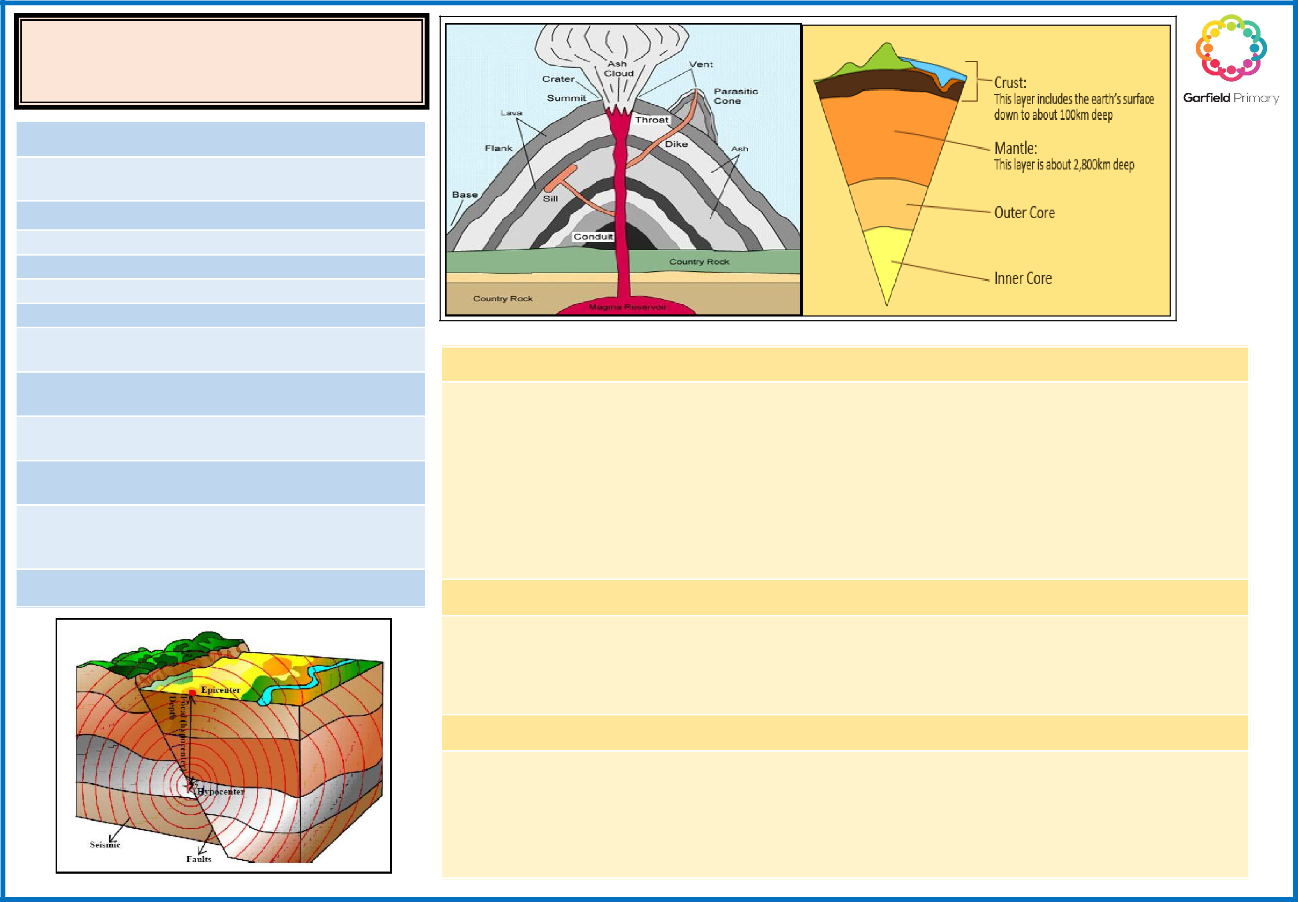
Knowledge Organiser—Year 3

Volcanoes and Earthquakes

Vocabulary

Volcano— an opening or rupture in the Earth’s crust through which lava, ash and gases escape.

Magma—a molten substance beneath the Earth’s crust.

Lava — molten , hot rock flowing from a volcano.

Crater— the mouth of a volcano.

Eruption— a volcano erupts when it shoots out lava Molten— hot, melted rocks.

Earthquake—a violent movement of parts of the Earth’s surface.

Epicentre— The point on the Earth’s surface at the centre of an Earthquake.

Earth’s crusts—the surface layer covering our planet.

There are 2 types of crust -oceanic and continental .

Earth’s mantle—under the crust is the mantle forming about half of the Earth.

Earth’s core - the core is at the centre of the Earth. There is a solid inner core and outer liquid core of molten metal.

Pompeii—a famous Roman city destroyed by a volcano. In 79 AD.

Key question: How are volcanoes and earthquakes created?

How are volcanoes formed?

- Magma rises through cracks or weaknesses in the Earth's crust.

- Pressure builds up inside the Earth.

- When this pressure is released, e.g. as a result of plate movement, magma explodes to the surface causing a volcanic eruption.

- The lava from the eruption cools to form new crust.

- Over time, after several eruptions, the rock builds up and a volcano forms.

Where are some of the world’s most famous volcanoes?

1.Mount Vesuvius, near Naples, Italy 2. Krakatoa, Indonesia ,

- Mount St. Helens, Washington, USA 4. Mount Tambora, Indonesia, 5. Mauna Loa, Hawaii

- Eyjafjallajökull, Iceland 7. Mount Pelée, Martinique,

What causes an earthquake?

An earthquake is the shaking and vibration of the Earth's crust due to movement of the Earth's plates (plate tectonics). Earthquakes can happen along any type of plate boundary.

Earthquakes occur when tension is released from inside the crust. Plates do not always move smoothly alongside each other and sometimes get stuck. When this happens pressure builds up. When this pressure is eventually released an earthquake tends to occur.

