Science – Year 1 Autumn 20
Knowledge Organiser: Ourselves/Animals
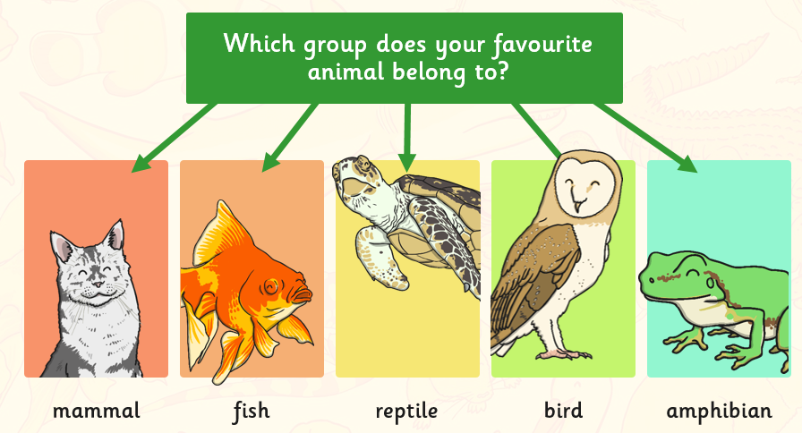
Key Words
Key question 1 | Body, head, hand, arm, foot, leg, chest, neck, face, shoulders, waist, elbow, knee
Key question 2/3 | Sense, sight, sound, touch, taste, smell, hear, see, eye, nose, mouth, tongue, fingers, ears.
Key question 4 | Claw, hoof, paw, flipper, antlers, horn, tusks, skin, fur, feathers, scales, wings, beak, gills, fin, tentacles.
Key question 5 | Carnivore, herbivore, omnivore.
Key Questions:
- What are the different parts of my body called?
- Which parts of my body do I use to see, smell, hear and taste?
- How can I sort animals into groups?
- How can I describe animals?
- What do I eat?

My Body
