Context of the School

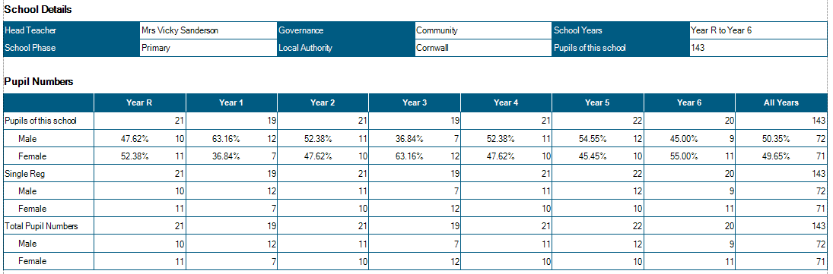

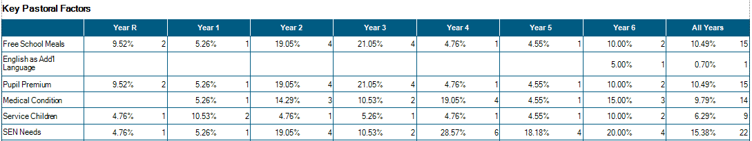

Attendance 6.1.21 – 8.3.21

Average attendance: 92% - for all children non-attending, email contact was made and improvements were seen in attendance.
Reasons for non attendance inc: Parents working/ illness/ drs appointments/ Internet access issues.

Persistent none attendance: 12 children (8%) for these children a variety of measures have been put into place:
- Delivering IT equipment and clear timetable of lessons to houses.
- Regular emails and calls for welfare checks
- Home visits
- Alternative differentiated materials printed and delivered
- Offers of school places

On-Line Learning Structure:

 | Registration | Session 1 | Session 2 | Session 3 | Session 4 | Session 5
Class 1 | Live registration | Pre-recorded English lesson | Maths video (White Rose) | Pre-recorded phonics lesson | Topic Based  Uploaded resources variety of pre-recorded or commercial  (Geog/ Hist/ PE/ Art/ Science/ IT/DT/ Music) | KS 1 bookshelf  Pre-recorded stories read by a variety of school staff.  Exp Friday – Live Catch-up / social time
Class 2 | Live registration | Pre-recorded English lesson | Maths video (White Rose) | Pre-recorded phonics lesson
Class 3 | Live registration | Live English lesson | Live Maths lesson | Independent study: TT rock starts, Handwriting, Spelling , completion of lesson work | Pre-recorded or commercial resources  (Geog/ Hist/ PE/ Art/ Science/ IT/DT/ Music) | Pre-recorded story time  Exp Friday – Live catch up/ games
Class 4 | Live registration | Live English lesson | Live Maths lesson |  |  | Pre-recorded story time  Exp Friday – Live catch up/ games
Class 5 | Live registration | Live English lesson | Live Maths lesson |  | Live Lesson  (Geog/ Hist/ PE/ Art/ Science/ IT/DT/ Music | Live catch up/ story
Class 6 | Live registration | Live English lesson | Live Maths lesson |  | Live Lesson  (Geog/ Hist/ PE/ Art/ Science/ IT/DT/ Music | Live catch up/ story

Key Worker/ Vulnerable (KWV) children provision:
33 Children registered for KWV provision (23%) significantly lower than other schools locally. Support staff have ensured that these children are cared for and have access to the same on line provision as the children working from home to ensure parity of provision and also to negate gaps in learning across the cohort where possible.

To date, we have supplied 21 lap tops to children, allowing them to access on online learning. DFE have supplied 6 laptops to school to support this process. We have also loaned 5x Chromebooks to Chacewater School to support KWV children in that setting.

From 8th March, classes will resume as follows:

Class Structure from
September 2020
Class 1:  EYFS -20 Year 1 - 10 | Mrs Mogridge (Mon – Wed)  Mrs French (Thurs-Fri)  Mrs Evans TA 08:45 – 3.00 pm  Mrs R Wilkes r 1:1 TA 08:45 – 3.00 pm  Miss Short TA 08:45 – 12.00 pm
Class 2:  Year 1 – 11 Year 2 – 16 | Mr Shainberg  Mrs Armstrong TA 9.00 – 3.15  Mr Collier 1:1 TA 9.00 – 3.15 pm
Class 3 Year 3 - 19 | Mrs Thomas (Mon-Wed)  Mr Sanderson (Thurs-Fri)  Mrs Medlin (9.00 – 12.15 pm )
Class 4 Year 4 - 21 | Mrs Wood  Mr Wilcox 1:1TA (M-F 9.00 – 3.15pm)
Class 5 Year 5 – 19 | Mr Martin  Mrs Stevens (Tues -Thurs – Fri 9.00 – 12.15 pm)
Class 6 Year 6 - 18 | Mr Collinge  Mrs Garland (Tues – Thurs 9.00 - 12.15)
PPA Cover  Subject leadership cover | Mr Mutsauers – PE Classes 2/4/5/6  Mrs Hamilton Classes 2/5/6  Mr Wilcox Class 4  Mr Mustaeurs
Intervention | Mrs Hamilton Monday 2.00 – 4.00pm Tuesday – Friday 1.00 – 4.oopm
Intervention | Miss Short Tues – Fri 1.00 – 2.30

Significant Changes/Challenges Since the last Head Teacher’s Report

- COVID19! Lockdown# 3 - please see Return to School Plan for full details of the school adaptations.
- On-line live and pre-recorded lessons in place from 7.1.21
- Very positive feedback from parents re: on-line learning with average of 92% attendance. (see appendix 1)
- Lateral Flow Testing twice weekly for staff (proposed 2x weekly for parents and pupils date TBC)
- 1 teacher employed on 2 terms contract after Mrs Wilkes left school.
- 2x in-year mobilities taking Class 2 to 31 ( agreed by Cornwall Council and exceptional circumstance)
- 1 x LTS resigned due to moving house.
- A small number of ‘bubble’ Christmas activities.
- Play equipment installed
- EYFS outside area currently being improved.
- Budget allocation for 2021-2022 increased by £63,000 due to increased per pupil funding from £2857 to £3123 and an increase in pupil number from 136 – 140 (now 143)

Quality of Education.

- Due to current circumstance monitoring of teaching and learning has been more complicated this term.
- Drop Ins from HT during late Nov and Dec showed that pupil engagement was high, children were keen to talk about their learning and to discuss prior learning with me.
- Continued work on curriculum development, ensuring progression and coverage was the primary focus during November – at this point all subjects were back on the curriculum plan after a brief period of ‘setting back into school’.
- Interventions in Maths and English continued for key children - taking place in the afternoons and after school (KS2) These interventions provided prime learning time for those identified children who had significant gaps in learning. Assessments showed that improvements were made in number bonds and times tables, and the four operations (with significant improvement in addition, subtraction and multiplication) . Improvements in phonics and reading were also trackable through 6 weekly assessments and AR reading scores.
- In KS1 intervention was focussed on phonics and nurture. Phonics Screening Check (PSC) in Dec showed that 81% of Y2 children passed their PSC – the average score for children who took the test was 37 (max score 40)
- All teachers have planned and prepared a yearly curriculum map which as much as possible has remained in place during lockdown – creativity of teachers and children has allowed for the continuation of subject such as Art – e.g. soap sculptures for Barbara Hepworth Study and DT – Roman Chariot making through time lapse videoing!
- The plan for child who need to isolate at home due to COVID19 remains in place – accessed through the website – active from 8.3.21

Behaviour and Attitudes
- With an Average of 92% attendance at live lessons and registrations, engagement in learning has been strong; notably strong in upper KS2 wherein children can independently access learning throughout the day and have greater resilience to on line learning.
- Pupils in Lower KS2 and KS1 have in the majority, worked incredibly hard and shared their learning with their teachers – this sending in of work remained strong until the week before returning to school, which saw a significant drop off.
- The very large majority of children, when asked, are keen to return to school and looking forward to spending time with their friends – this social focus is very important as pupils return and for the first 2 weeks our curriculum will be restricted to Core subject, PE and PSHE – this will give time for children to re-establish social links, gain resilience for learning and being in the classroom (Inc. sitting still for longer periods of time, listening to and following instructions, writing for longer periods etc.)
- A few parents are concerned about the health and well-being of their children returning – children are expressing anxiety and concern. Learning from lockdown #1 would suggest that as soon as these children are able to return to school, these anxieties will reduce – however, teachers are aware of and

- will support individuals whose anxiety levels are significant (current estimations are approx. 12 children)

We currently have:
- 1 x child with a Special Guardianship Order
- 1x child with active court order.
- 1x child is currently working with social care
- 1x TAC plan in place
- 1x EHH referral since the last HT’s report
- 1 child working with CAMHS

- There have been no Incidences of team teach physical intervention this half term.

Personal Development and Cultural Capital

- We continue to work with Primary Futures, in order to present the children in Y6 the opportunities to understand better the range of career opportunities that is available to them in their local environment.
- British Vales (BV) are taught through all curriculum areas, with a focus on the PSHE curriculum wherein BV are highlighted every week and a map of coverage is in place to ensure that we meet these foci.
- Andrew Martin is tasked with linking our school to a range of other schools across the world – through registration with the British Council – the time scale for this has been increased due to schools globally being disrupted.
- The further (and more considered) use of our outside spaces and community areas (the playing fields/ forest school/ Flushing beach etc) have promoted physical activity and mental health and wellbeing for our children (and staff). The Play-platform has been re-purposed into an outside classroom.
- Children now eat lunches in the classrooms (KS2) which allows weekly updates on current affairs and world news. This time is also used to further support English – through listening to the class text.
- Playtimes continue to be split by bubbles and this allows very positive play for our children – in a space that is not so crowded and dominated by football.
- The playground equipment has been installed and the KWV children have given very positive feedback re. this resource.

In order for staff to continue to remain up-to-date and be empowered to move our school forwards, a comprehensive, SDP-based CPD programme has been put into place – however due to COVID19 restrictions much of this learning is on hold.

CPD: This year to date:
Matt Collinge and Andrew Martin have attended Maths Hub Training
All staff have completed Tier 1 safeguarding update.
All staff have completed in house attachment disorder training and separation anxiety training
All staff have completed APDR training
Kate and Matt have had some time with our SENCo to discuss her role.
VS worked with the CC H+S officer to complete audit of our school.
Sophie has completed first aid at work training.
VS – SIP training.
VS – supported HT appraisal process @ Mawnan School
VS – working with Kernow Teaching School and SIP advisor
SW – Enrolled on Trauma Informed Schools Training (completed 2x days)
All teaching staff have updated training on identification and support of SEND pupils.

Effectiveness of Leadership and Management

Focus for this year – in line with the OFSTED guidelines – has been the remapping of the curriculum to ensure that we have a broad and balanced offer.
Staff have audited and re-mapped content to ensure progress and coverage – supported by the Essentials Curriculum.
Governors have met with subject leads in order to help triangulate policy/ planning/teaching/learning/assessment.
Teachers have planned subject leadership time throughout the year in order to be able to monitor lessons and standard of work in books – the logistics of this are proving a little tricky, but observation from afar and pupil conferencing outside has allowed for this to take place in both KS 2 Science, Maths, KS 1 Music.
Andrew continues to work with the Cornwall and West Devon Maths Hub
This year all subject leaders have planned release time, in order to: monitor lessons, content and planning; gain feedback from children; give feedback to staff; speak with link governors – this time will resume post lockdown #3
I have been asked to work with the Kernow Teaching School to support 3x schools in Requires Improvement – this will bring a small revenue in to the school and also provide me with an exterior focus and training opportunity.
Our new SIP – Mark Lees, joins us on the 15.3.21 for an orientation visit – we are very much looking forward to working with him.

